**Visualization of Wikipedia :-**

**I have changed the globe and map to D3js and added Network graph.**

**Index.html:-**

Main page with rotating globe.

The Globe is developed using D3js.

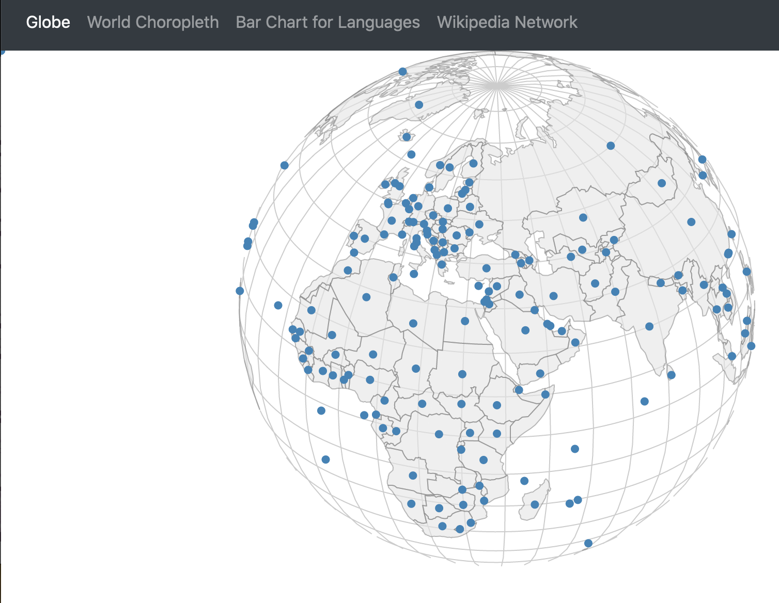

**Worldwikichoro.html:-**

Choropleth world map with world wide usage of wikipedia, on hover we can see country, percentage, total views, percentage of people connected to wikipedia, population.

Developed in D3js

**Stackedbarchart.html:-**

Developed in D3js.

Barchart represents the number of Edits per language for October month. Data is directly collected from wikipedia.

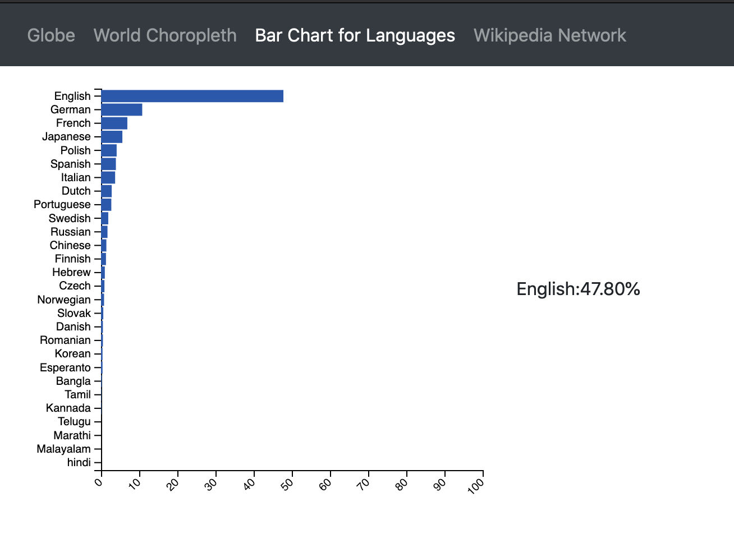

**Network graph.html:-**

Network graph is developed using D3js.

Network graph represents the traffic of wikipedia for a single work chameleon.

